

CSA1735 – ARTIFICIAL INTELLIGENCE

SLOT A
LAB EXPERIMENTS

KAUSHIK NARAYANAN V - 192321047
FACULTY
Dr. Thalapathi Rajasekaran R

Experiment 1- 8 PUZZLE
Aim
To write a Python program to solve the 8-Puzzle problem using the A* search algorithm.
Algorithm
- Start with the initial state of the puzzle and the goal state.
- Represent the empty tile as 0.
- Calculate the heuristic value using the Manhattan distance of each tile from its goal position.
- Calculate the evaluation function \(f(n)=g(n)+h(n)\), where \(g(n)\) is the path cost and \(h(n)\) is the heuristic cost.
- Select the state with the lowest evaluation value.
- Generate possible states by moving the empty tile up, down, left, or right.
- Repeat until the goal state is reached.
- Display the sequence of puzzle states.
Program

import heapq

start = (1, 2, 3, 4, 0, 6, 7, 5, 8)
goal = (1, 2, 3, 4, 5, 6, 7, 8, 0)

def heuristic(state):
distance = 0
for i in range(9):
if state[i] != 0:
j = goal.index(state[i])
distance += abs(i // 3 - j // 3)
distance += abs(i % 3 - j % 3)
return distance

def solve():
queue = [(heuristic(start), 0, start, [])]
visited = set()

while queue:
f, cost, state, path = heapq.heappop(queue)

if state in visited:
continue
visited.add(state)
path = path + [state]

if state == goal:
for s in path:
for i in range(0, 9, 3):
print(s[i:i+3])
print()
return

zero = state.index(0)
r, c = zero // 3, zero % 3

for dr, dc in [(1, 0), (-1, 0),
(0, 1), (0, -1)]:
nr, nc = r + dr, c + dc

if 0 <= nr < 3 and 0 <= nc < 3:
new_zero = nr * 3 + nc
new_state = list(state)
new_state[zero], new_state[new_zero] = (
new_state[new_zero], new_state[zero]
)
new_state = tuple(new_state)

if new_state not in visited:
new_cost = cost + 1
heapq.heappush(
queue,
(new_cost + heuristic(new_state),
new_cost, new_state, path)
)
solve()

Output
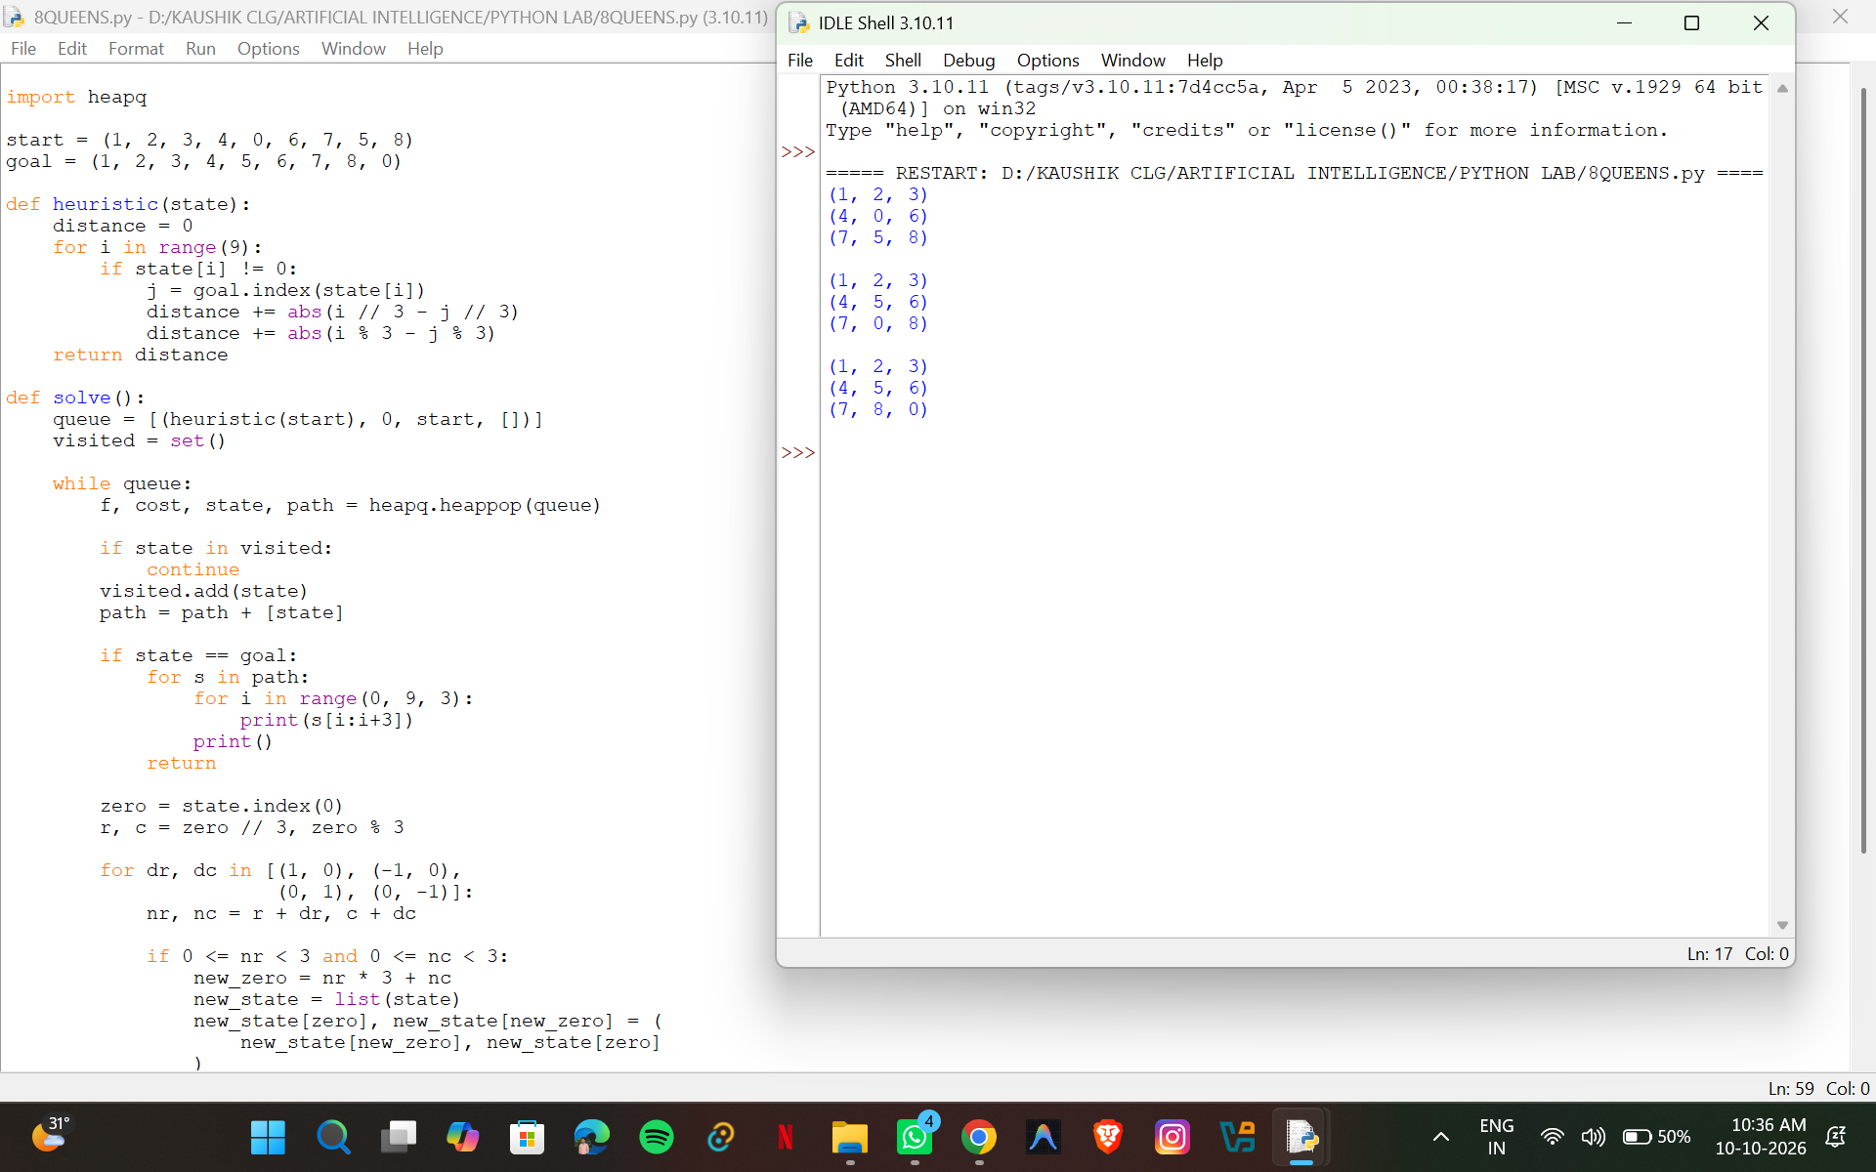
Result: The 8-Puzzle problem is solved successfully using the A* search algorithm.

Experiment 2: 8-Queen Problem
Aim
To write a Python program to solve the 8-Queen problem using the backtracking technique.
Algorithm
- Start with an empty chessboard.
- Place a queen in the first row.
- Check whether the selected column is safe from other queens.
- Ensure that no two queens share the same column or diagonal.
- If the position is safe, place the queen and move to the next row.
- If no safe position exists, backtrack to the previous row.
- Repeat until eight queens are placed successfully.
- Display the chessboard.
Program

N = 8
board = [-1] * N

def safe(row, col):
for r in range(row):
if board[r] == col:
return False
if abs(board[r] - col) == abs(r - row):
return False
return True

def solve(row):
if row == N:
return True

for col in range(N):
if safe(row, col):
board[row] = col

if solve(row + 1):
return True

board[row] = -1

return False

if solve(0):
for r in range(N):
for c in range(N):
if board[r] == c:
print("Q", end=" ")
else:
print(".", end=" ")
print()
else:
print("Solution not found")
Output
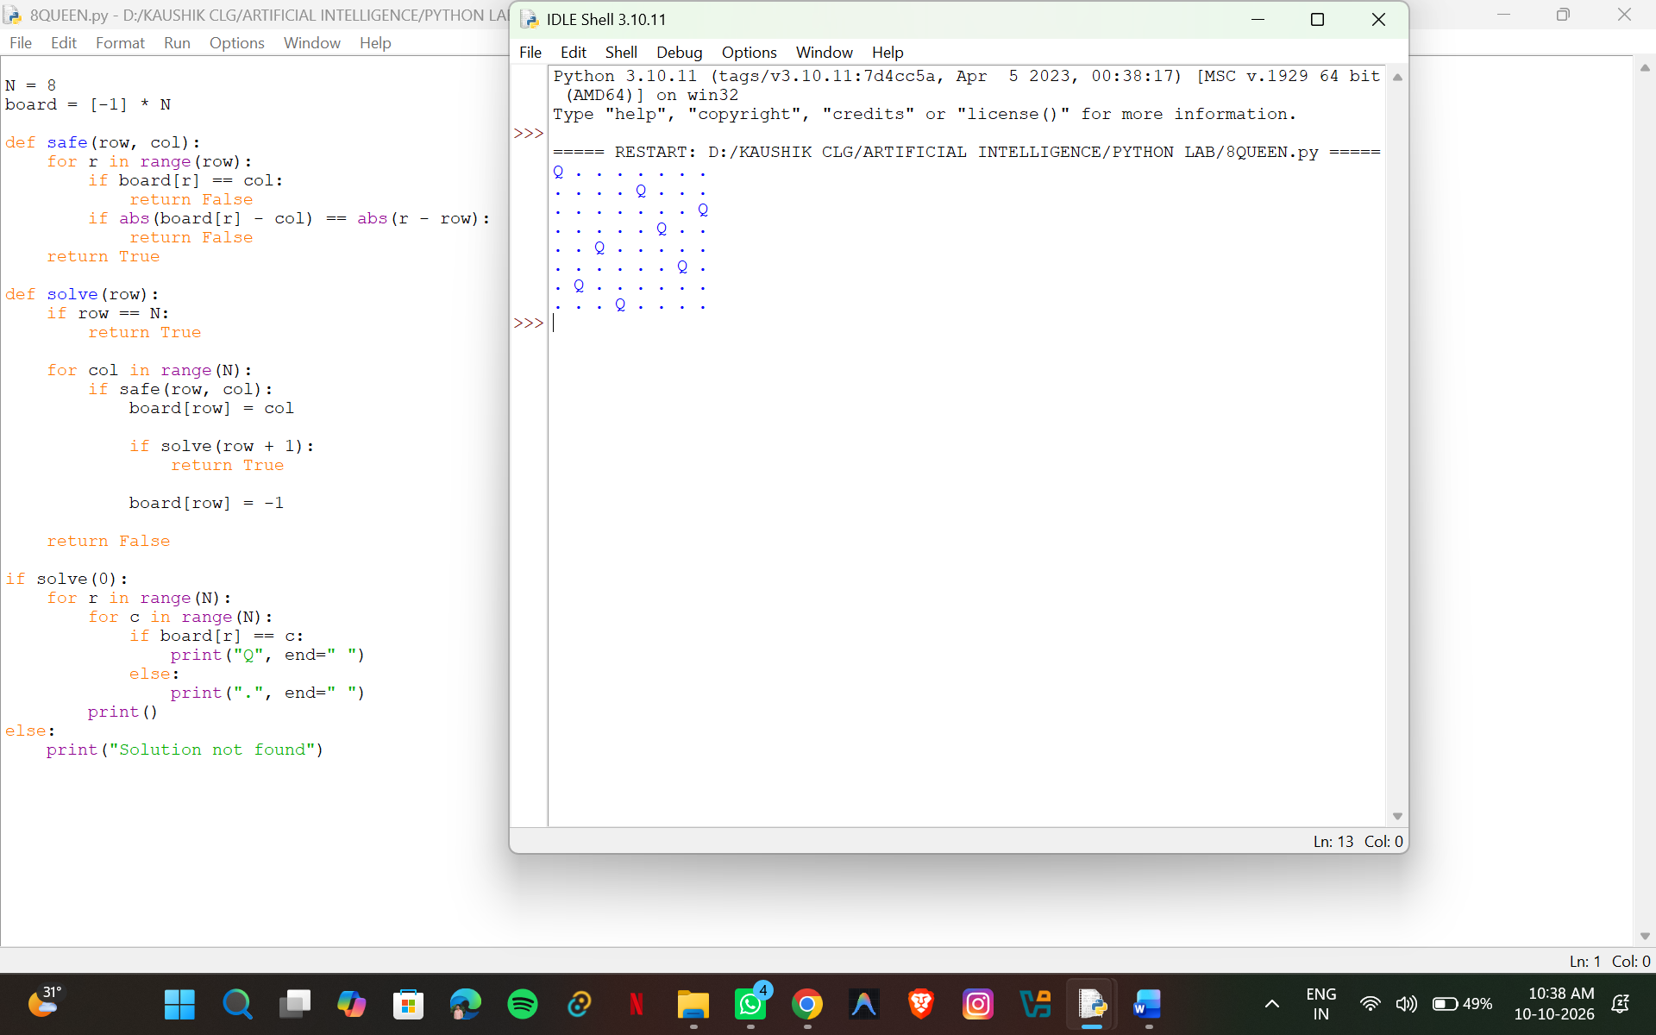Result: The 8-Queen problem is solved successfully using backtracking.
Experiment 3: Water Jug Problem
Aim
To write a Python program to solve the Water Jug problem using the Breadth-First Search (BFS) algorithm.
Algorithm
- Initialize two water jugs with capacities of 4 litres and 3 litres.
- Set the initial state as (0, 0).
- Define the goal as obtaining 2 litres of water in either jug.
- Generate possible states by filling a jug, emptying a jug, or pouring water from one jug into the other.
- Add each unvisited state to a queue.
- Repeat until the goal state is reached.
- Display the sequence of states.
Program

from collections import deque

def water_jug():
capacity1 = 4
capacity2 = 3
start = (0, 0)

queue = deque([(start, [start])])
visited = {start}

while queue:
(a, b), path = queue.popleft()

if a == 2 or b == 2:
print("Solution:")
for state in path:
print(state)
return

amount = min(a, capacity2 - b)
amount2 = min(b, capacity1 - a)

states = [
(capacity1, b),
(a, capacity2),
(0, b),
(a, 0),
(a - amount, b + amount),
(a + amount2, b - amount2)
]

for state in states:
if state not in visited:
visited.add(state)
queue.append((state, path + [state]))

water_jug()

Output
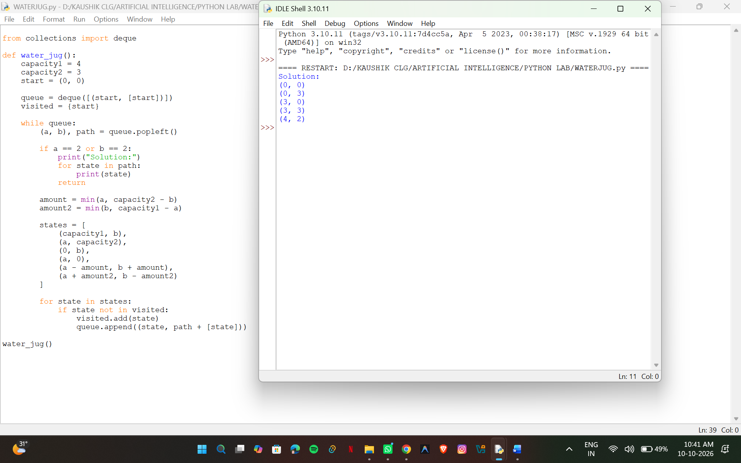Result: The Water Jug problem is solved successfully using BFS to obtain 2 litres of water.
Experiment 4: Crypt-Arithmetic Problem
Aim
To write a Python program to solve the crypt-arithmetic problem SEND + MORE = MONEY using backtracking and digit assignment.
Algorithm
- Identify the unique letters in the words SEND, MORE, and MONEY.
- Assign a different digit from 0 to 9 to each letter.
- Ensure that the first letters S and M are not zero.
- Convert the words into their corresponding numbers.
- Check whether the equation SEND + MORE = MONEY is satisfied.
- If the equation is true, display the digit assignments and the arithmetic result.
- Otherwise, continue searching for another assignment.
Program

from itertools import permutations

letters = "SENDMORY"

for p in permutations(range(10), len(letters)):
d = dict(zip(letters, p))

if d["S"] == 0 or d["M"] == 0:
continue

send = 1000*d["S"] + 100*d["E"] + 10*d["N"] + d["D"]
more = 1000*d["M"] + 100*d["O"] + 10*d["R"] + d["E"]
money = (10000*d["M"] + 1000*d["O"] +
100*d["N"] + 10*d["E"] + d["Y"])

if send + more == money:
print("SEND =", send)
print("MORE =", more)
print("MONEY =", money)
break

Output
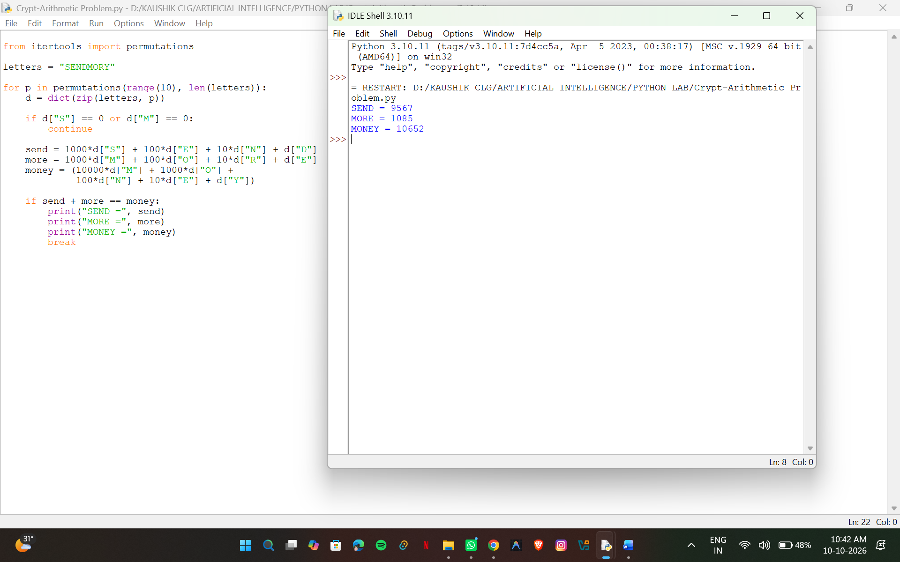
Result: The crypt-arithmetic problem is solved successfully by assigning unique digits to the letters.
Experiment 5: Missionaries and Cannibals Problem
Aim
To write a Python program to solve the Missionaries and Cannibals problem using the Breadth-First Search (BFS) algorithm.
Algorithm
- Initialize three missionaries and three cannibals on the left bank of the river.
- Place the boat on the left bank with a capacity of two people.
- Generate possible boat movements carrying one or two people.
- Ensure that cannibals never outnumber missionaries on either bank when missionaries are present.
- Use BFS to explore all valid states without revisiting previously explored states.
- Continue until all missionaries and cannibals reach the right bank.
- Display the sequence of valid states.
Program

from collections import deque

start = (3, 3, 1)
goal = (0, 0, 0)

moves = [(1, 0), (2, 0), (0, 1),
(0, 2), (1, 1)]

def valid(m, c):
mr = 3 - m
cr = 3 - c

return (0 <= m <= 3 and 0 <= c <= 3
and (m == 0 or m >= c)
and (mr == 0 or mr >= cr))

def solve():
queue = deque([(start, [start])])
visited = {start}

while queue:
state, path = queue.popleft()
m, c, boat = state

if state == goal:
for s in path:
print(s)
return

for dm, dc in moves:
if boat == 1:
new_state = (m - dm, c - dc, 0)
else:
new_state = (m + dm, c + dc, 1)

if valid(new_state[0], new_state[1]):
if dm + dc >= 1 and new_state not in visited:
visited.add(new_state)
queue.append(
(new_state, path + [new_state])
)

solve()
Output
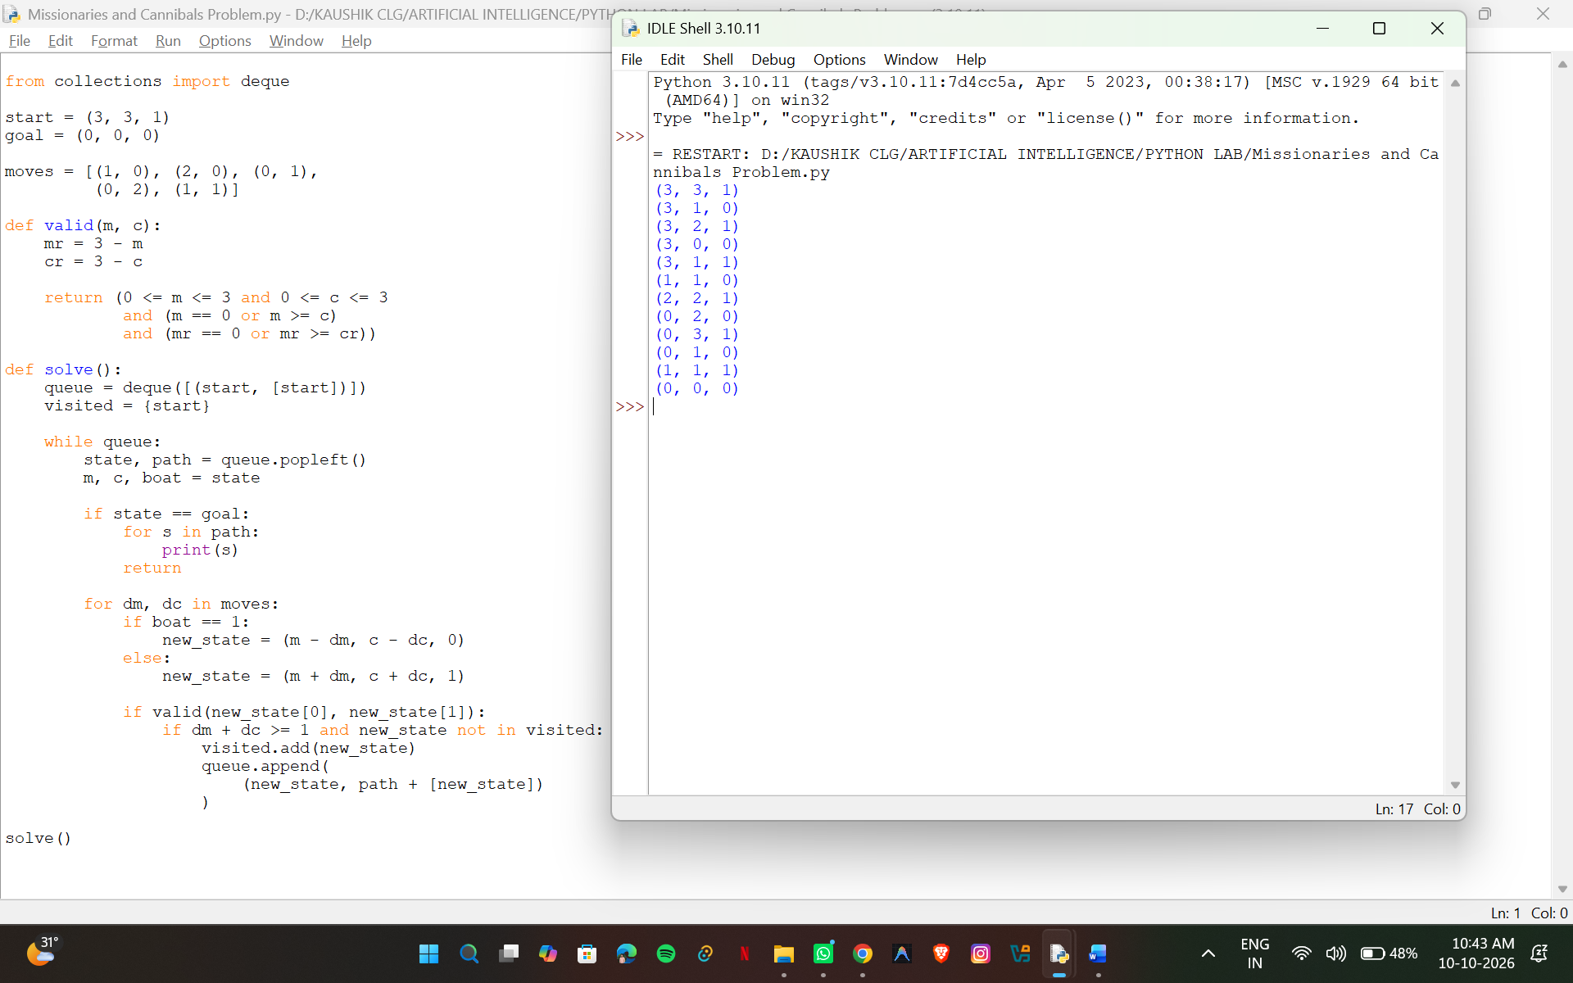
Result: The Missionaries and Cannibals problem is solved successfully using BFS while satisfying the safety constraints.

